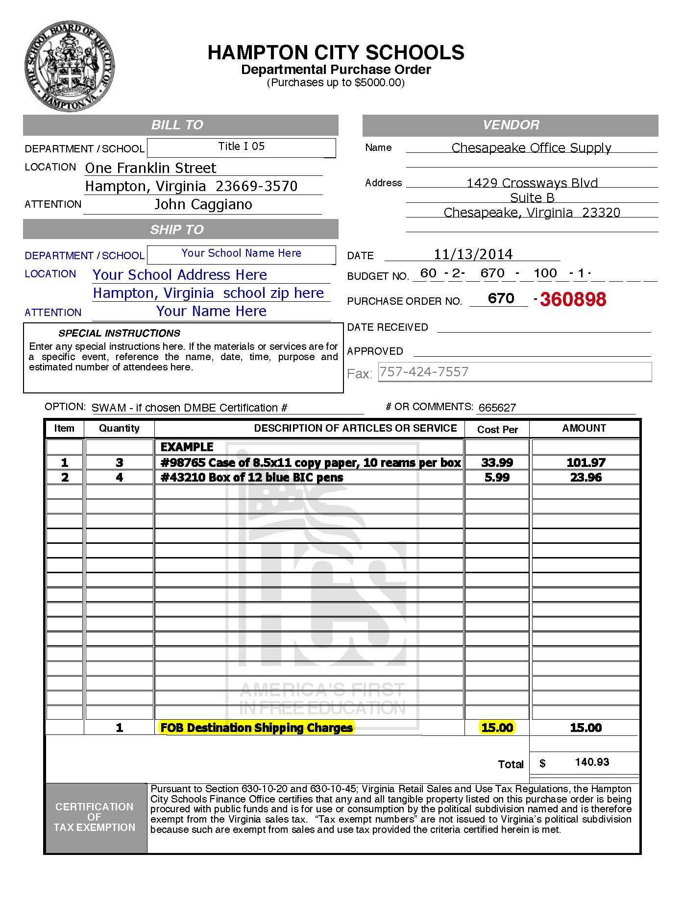

Include all shipping and handling charges, if any.

Account code here. Title I dept. will enter if unsure.

**SAMPLE**